Match and INDEX Function

Match function

MATCH is an Excel function used to locate the position of a lookup value in a row, column, or table. MATCH supports approximate and exact matching, and **wildcards** (* ?) for partial matches. Often, MATCH is combined with the **INDEX function** to retrieve a value at a matched position.

**Purpose**

Get the position of an item in an array

**Return value**

A number representing a position in lookup_array.

**Syntax**

=[MATCH](https://exceljet.net/functions/match-function)(lookup_value,lookup_array,[match_type])

* *lookup_value* - The value to match in lookup_array.
* *lookup_array* - A range of cells or an array reference.
* *match_type* - [optional] 1 = exact or next smallest (default), 0 = exact match, -1 = exact or next largest.

**How to use**

The MATCH function is used to determine the *position* of a value in a range or **array**. For example, in the screenshot above, the formula in cell E6 is configured to get the position of the value in cell D6. The MATCH function returns 5 because the lookup value ("peach") is in the 5th position in the range B6:B14:

=[MATCH](https://exceljet.net/functions/match-function)(D6,B6:B14,0) // returns 5

The MATCH function can perform exact and approximate matches and supports **wildcards** (* ?) for partial matches. There are 3 separate match modes (set by the *match_type*argument), as described below.

**Match type information**

Match type is optional. If not provided, *match_type* defaults to 1 (exact or next smallest). When *match_type* is 1 or -1, it is sometimes referred to as an "approximate match". And 0 for the exact match

*Note: the MATCH function will always return the first match. If you need to return the last match (reverse search) see the***XMATCHfunction***. If you want to return all matches, see the***FILTERfunction***.*

MATCH only supports one-dimensional **arrays** or **ranges**, either vertical or horizontal. However, you can use MATCH to locate values in a two-dimensional range or table by **giving MATCH the single column** (or row) that contains the lookup value. You can even **use MATCH twice in a single formula** to find a matching row and column at the same time.

Frequently, the MATCH function is combined with the **INDEX function** to retrieve a value at a certain (matched) position. In other words, MATCH figures out the *position*, and INDEX returns the *value at that position*. For a detailed overview with simple examples, see **How to use INDEX and MATCH**.

### Exact match

When match_type is zero (0), MATCH performs an exact match only. In the example below, the formula in E3 is:

=[MATCH](https://exceljet.net/functions/match-function)(E2,B3:B11,0) // returns 4

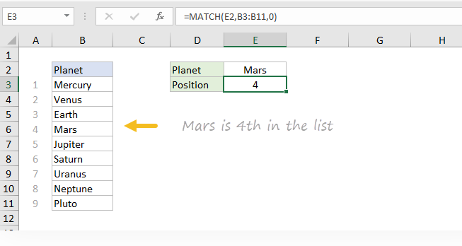

In the formula above, the lookup value comes from cell E2. If the lookup value is hardcoded into the formula, it must be enclosed in double quotes (""), since it is a text value:

=[MATCH](https://exceljet.net/functions/match-function)("Mars",B3:B11,0)

*Note: MATCH is not case-sensitive, so "Mars" and "mars" will both return 4.*

### INDEX and MATCH

The MATCH function is commonly used together with the [**INDEX function**](https://exceljet.net/functions/index-function). The resulting formula is called "INDEX and MATCH".  For example, in the screen below, INDEX and MATCH are used to return the cost of a code entered in cell F4. The formula in F5 is:

=[INDEX](https://exceljet.net/functions/index-function)(C5:C12,[MATCH](https://exceljet.net/functions/match-function)(F4,B5:B12,0)) // returns 150

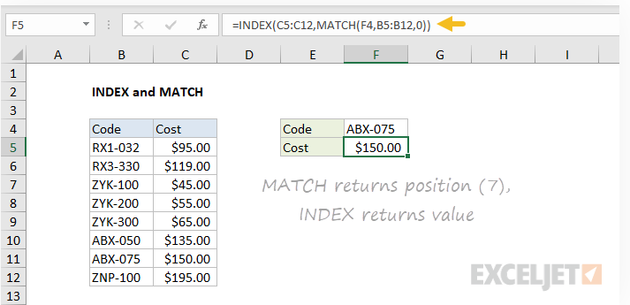

In this example, MATCH is set up to perform an exact match. The MATCH function locates the code ABX-075 and returns its position (7) directly to the INDEX function as the row number. The INDEX function then returns the 7th value from the range C5:C12 as a final result. The formula is solved like this:

=[INDEX](https://exceljet.net/functions/index-function)(C5:C12,[MATCH](https://exceljet.net/functions/match-function)(F4,B5:B12,0))

=[INDEX](https://exceljet.net/functions/index-function)(C5:C12,7)

=150

See below for more examples of the MATCH function. For an overview of how to use INDEX and MATCH with many examples, see:  [**How to use INDEX and MATCH**](https://exceljet.net/articles/index-and-match).

### Notes

* MATCH is not case-sensitive.
* MATCH returns the #N/A error if no match is found.
* MATCH only works with text up to 255 characters in length.
* In case of duplicates, MATCH returns the first match.
* If match_type is -1 or 1, the **lookup_array** must be sorted as noted above.
* If **match_type** is 0, the **lookup_value** can contain the [**wildcards**](https://exceljet.net/glossary/wildcard).
* The MATCH function is frequently used [**together with the INDEX function**](https://exceljet.net/articles/index-and-match).